Diogeness was a scanning flat crystal scanning spectrometer and photometer. The scanning range of the spectrometer covered 140 arcmin. The instrument had four measurement channels. Details concerning the crystal used and wavelength ranges covered are given in Table 1.

**Table 1:** Diogeness Characteristics

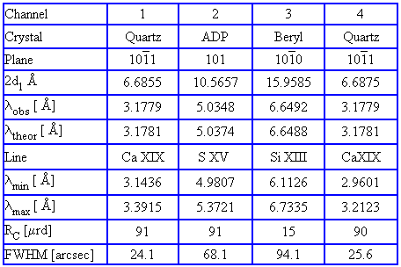

During intense flares spectra were sampled about twice faster than normally (0.4 s). Two of the crystals used in Diogeness are identical Quartz, mounted in the so-called Dopplerometer configuration. Such arrangement of the crystals allowed to precisely measure expected flare related Doppler shifts of X-ray lines. For the source plasma being at rest, the maxima of lines scanned in opposite directions would be measured nearly simultaneously. If any radial motions were present, the lines were off-set in time. The relative off-set can be directly translated to the solar plasma velocities.

RESIK is the bent crystal spectrometer designed to cover the spectral range below 6 Å with the aim to measure line and continuum fluxes for many lines belonging to ions with atomic numbers 30 > z > 14. The crystals used as dispersive elements are thin wafers (0.5 mm and 1 mm) of silicon and quartz monocrystals of large area (Table 2). The wavelength channels of RESIK spread over ten different spectral bands (including higher order reflections) covering almost entirely 1.1 Å - 6.1 Å range. The crystals are bent to a convex cylindrical profiles ­ since this geometry allows to reduce the overall size of the crystal­-detector assembly. As a consequence of the wavelength coverage selected, the widths of most of the lines to be measured are defined (in the first order of reflection) by the detector bin widths which means that the observed line widths are larger than respective physical widths. The crystals selected for the spectrometers were chosen because they were not expected to be a subject to fluorescence. Previous spectrometers have had problems with background flux caused by photons emitted from diffracting crystals when they were illuminated with energetic photons (E  > 11.2 keV in case of germanium crystals).