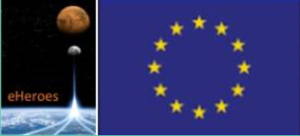

**eHeroes – MS19**

**Creation of a database of particle**

**environment signal from CORONAS and Proba-2 data**

Goals To reach:

* To create dedicated databases of particle environment on polar orbits.
* To analyze particle effects on data and instruments.

Initial version of the database has been released and is available at

<http://www.cbk.pan.wroc.pl/body/grants/eHEROES/DATABASE_OF_PARTICLE_ENVIRONMENT/>

At the moment the database contains particle data from SphinX and RESIK instruments which operated on CORONAS satellites. The final database release will contain also particle data from other CORONAS-F and PROBA2 instruments. Basic information on missions used to study particle environment at LEO orbits is given in Table 1. Mission lifetimes are shown in Figure 1.

**Table 1.** Basic information on missions used to study particle environment at LEO orbits.

|  |  |  |  |
| --- | --- | --- | --- |
| SATELLITE | CORONAS-F | CORONAS-Photon | PROBA2 |
| Mission duration | 31.08.2001– 05.12.2005 | 31.01-2009 –  30 .11.2009 | 02.11.2009 -  present |
| LEO Orbit height [km] | 550/500 | 575/550 | 728 |
| Orbit inclination angle [deg] | 82.5 | 82.5 | 98.3 |
| Initial orbital period [min] | 95 | 96 | 100 |

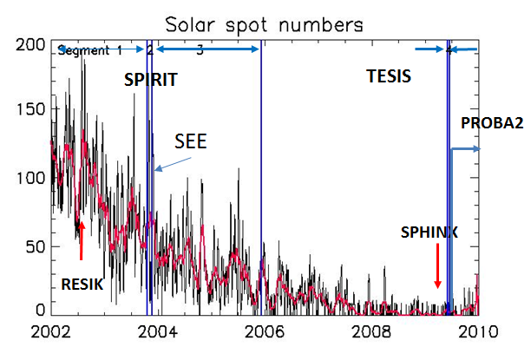

**Figure 1.** SPIRIT, TESIS, RESIK and SphinX instruments and PROBA2 satellite mission lifetimes. Plot with average sunspot number is shown in the background.

**Partner contributions: LPI- contributions**

1. The method of separating spikes produced by charged particles from tracks of space debris in the solar EUV images obtained by space orbital telescopes has been developed.

2. The data obtained with the SPIRIT EUV telescope (6 EUV channels) during the flight of CORONAS-F at solar maximum (2001-2005) have been processed and analyzed. The charged particle effects were classified and parameterized.

3. It was found that the mean day rate of CP-produced spikes in this period (except enhancements due to sporadic solar activity) was ~200 times lower than that registered by TESIS on CORONAS-Photon during the period of solar minimum (2009). The anomalous density of spikes (up to 10^4 in one image) was detected in November 2003 when they were produced by powerful flares and CMEs. The largest spike density for SPIRIT as well as for TESIS corresponded to the SAA region. The spatial distribution of the spike rate during the period of anomalous solar activity in October - November 2003 differs from that predicted by SPENVIS due to enhancements produced by the events of spontaneous solar activity. It was also found that the mean intensity and track length (the particle’s measured energy) at solar maximum and at solar minimum are nearly the same.

4. The results were presented in the joint LPI-SRC PAS report at the SPENVIS User Workshop on May 22-24, 2013.

**Further works:**

- Comparison of the obtained results with the SPENVIS predictions;  
- Inclusion particle data from of LPI instruments on CORONAS satellites.   
- Analysis and dissemination of particle data.

Graphical illustrations of above described results are in the figures below

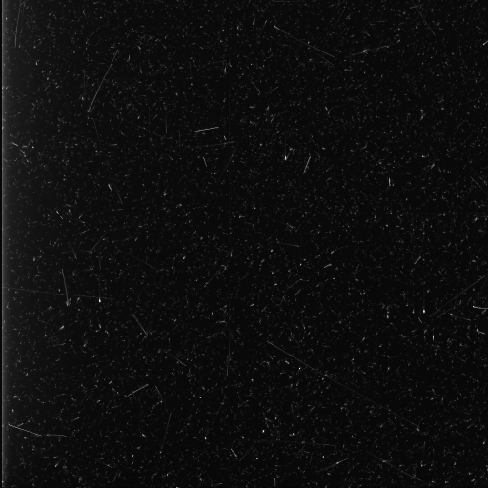

**Figure 2.** Contribution of particle signal seen in dark images of SPIRIT during occulted portions of satellite orbit. Image was taken on 5 November 2001.

**Figure 3.** Combined data from SPIRIT/CORONAS-F H171, H195, H284, H304, R175, R304 channels for the period from August 2001 until May 2004. Mean particle flux: <P> ≈ 10-3 DN/cm2/s (0.02 spikes/pix/day), peak particle flux: Pmax = 0.2 DN/cm2/s.

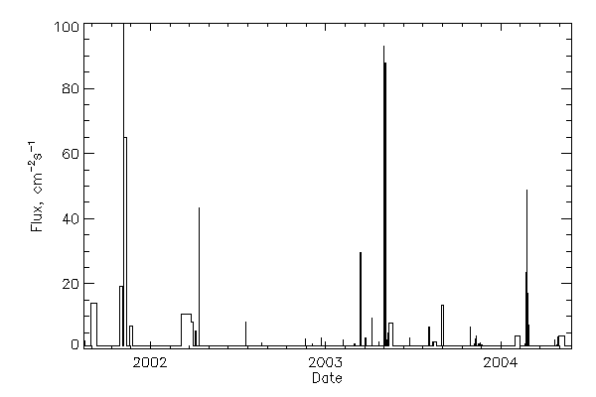

Strong flares

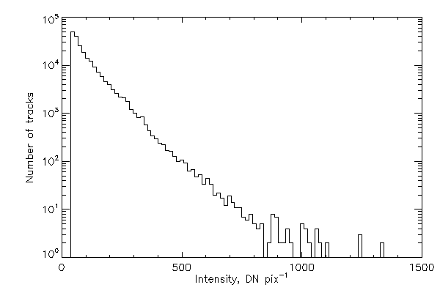

**Figure 4.** Number of particle tracks observed on CCD plotted vs track intensity. Combined data from SPIRIT/CORONAS-F H171, H195, H284, H304, R175, R304 channels for the period from August 2001 until May 2004 were used for this plot. Mean particle track intensity is <I> ≈ 250 DN/pixel.

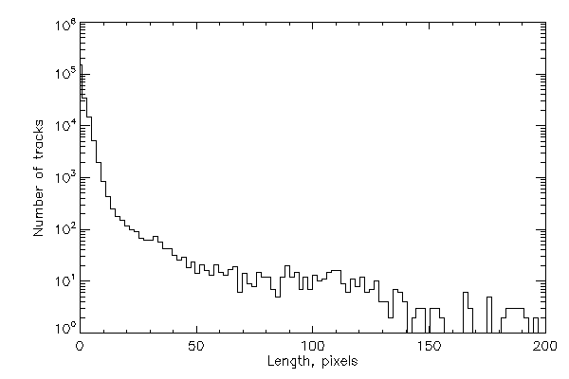**Figure 5.** Number of particle tracks observed on CCD plotted vs track length. Combined data from SPIRIT/CORONAS-F H171, H195, H284, H304, R175, R304 channels for the period from August 2001 until May 2004 were also used for this plot. Mean length of particle track is <L> ≈ 2 pix ≈ 30 μm, maximum length is Lmax ≈ 400 pixels (6 mm)

**Figure 6.** Maps of CP-produced spikes in the SPIRIT images and the SPENVIS radiation fluxes

**Partner contributions: SRC-PAS contributions**

* **specific goals for the first half of the project;**

Reduction of RESIK and SphinX particle data

Geometrical modeling of SphinX detectors and surrounding shielding in GEANT 4 platform.

Review of available particle data sets and identification of possible analysis directions.

Preparation of initial form of database of particle environment on LEO orbits.

Development of software tools for the particle data reduction and analysis.

* **specific goals for the last part of the project;**

Analysis of energetic particle environment and its variability on CORONAS-F and CORONAS – Photon, PROBA2 satellite. orbit using RESIK and SphinX data.

Preparation of the full operational database of particle environment on LEO orbits - deliverable D5.5 in cooperation with other partners

* **status and progress in your deliverable, interaction with other WPs;**

The first results of particle data reduction from RESIK and SphinX instruments have been shown during meeting at ROB 3-4 may 2012. The possible shapes and formats of the online database and analysis of the variability of particle environment were also discussed during this meeting. Initial comparison of RESIK and SphinX particle observations have been made.

Works on online database and analysis of the variability of particle environment is in progress. Format of particle data is agreed between all participants. Web interface to of this database is under construction. First particle database operational version will be released in September 2013 together with online report MS19.

The initial and full version of the database will be available for WP-6 (dissemination) eHeroes WP.

Systematic analysis of the particle records (PHA) from RESIK instrument has been started.

Electron flux dynamics in SAA and radiation belts was investigated using SPHINX and STEP-F instrument data.

Geometrical modeling of SphinX detectors and surrounding shielding in GEANT 4 platform have been performed.

Maps for RESIK particle observations have been prepared for all RESIK gas filled detectors and particle PIN diodes detectors.

Comparison of the Earth energetic particle environment as seen by RESIK and SphinX is in progress.

Necessary software tools have been developed.

* **how this progress will lead to eventual success on all deliverables;**

Simulations in GEANT 4 platform will help to better understand SphinX response to particle signal thus allowing for more extended data analysis.

For the first time, a full RESIK dataset has been compiled containing all measurements performed by this instruments. The dataset size is ~30 GB in one IDL *.sav file. This dataset will be used for further analysis of solar X-ray line & continuum emission as well as the particle environment of the magnetosphere at the Coronas-F orbital shell.

Progress on particle data identification, reduction and performed simulations will allow to establish first operational database of particle observations (the Task deliverable). The database will have flexible structure It will be possible to add particle measurements from other instruments to its content.

* **describe the problems (if any) and how they were (or will be) solved.**

At the moment there are no problems.

Graphical illustrations of above described results are in the figures below

**Figure 1.** Example of particle data and housekeeping data for SphinX D2 detector.

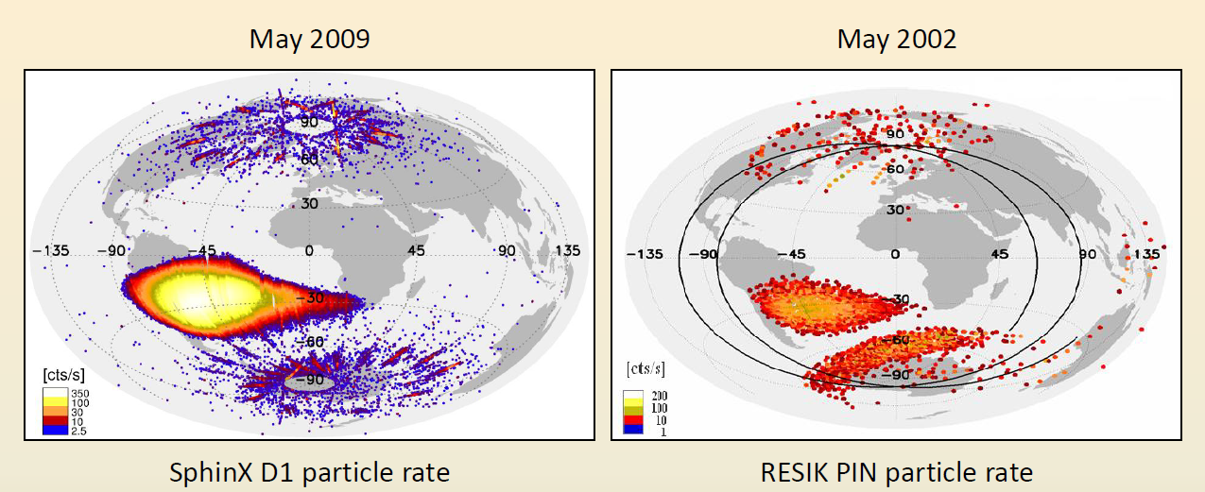**Figure 2.** Comparison of particle map as seen by RESIK and SphinX.

**Partner contributions: ROB contributions**

* **specific goals for the first half of the project;**

Identification of particle signal in PROBA2/LYRA data.

Prototype tools to automatically detect those perturbations have been implemented, but need to be refined and tested.

Since the beginning of the project, PROBA2/LYRA data have been also analyzed to detect perturbations that could be attributed to the impact of the Earth’s environment. Three types of perturbations have been identified so far:

* Atmospheric extinction when the spacecraft experiences occultations (analyzed in the frame of eHeroes WP 5.6)
* Perturbations in the South Atlantic Anomaly
* Temporary perturbations in the auroral zones

In this WP, ROB partners focused on studies of the two last ones. Results of particle data analyzes obtained in the first part of the eHerooes project indicate that

Perturbations in SAA seem to be caused by protons:

* They are detected independently of the pointing direction and on the covers status
* They do not dependent on the observed spectral range
* Their amplitude depends on the detector material/type (Silicon vs Diamond)
* The absolute amplitude of perturbation seems constant over the mission (~0.5 counts/ms in Si, ~0.05 counts/ms in MSM diamond)

Perturbations in the auroral zones are not yet understood:

* They occur 2-3 days after a CME, big flare ...
* They are associated to high Kp index
* They are only observed in SXR-EUV channels
* The absolute amplitude of the perturbations seems to decrease with time, as the instrument degrades
* So far, they were never detected while covers are closed
* **specific goals for the last part of the project;**

Further reduction of the PROBA2 particle data

Interpretation and analysis of PROBA2 particle data

Graphical illustrations of above described results are in the figures below

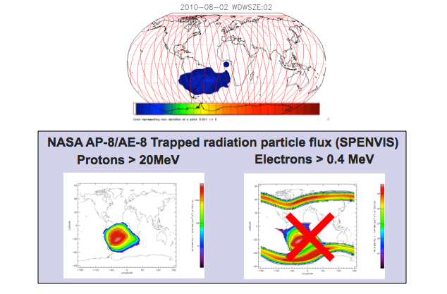

Figure 1: Perturbations in the SAA as detected by LYRA on 2010-08-02, as compared to models of populations of protons and electrons.

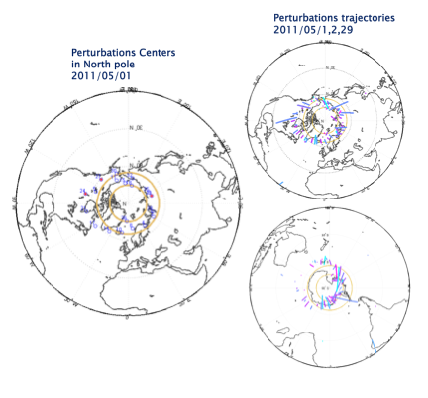

Figure 2: Locations of auroral perturbations on May 1, 2, and 29 2011.

**Additional information**

During the conference “Progress on EUV & X-ray spectroscopy and imaging” <http://www.cbk.pan.wroc.pl//conferences/conference_nov_2012/> a round table on eHeroes was organized. Progress on common deliverables, including D55 deliverable, and further steps were discussed with eHeroes partners.

## Student Training at ROB:

“Analysis of the interference signal observed by the radiometer LYRA during high magnitude magnetic storms“, IRAGUHA Jean Paul, Ecole polytechnique de Bruxelles (Dec 2012)

**PUBLICATIONS AND PRESENTATIONS OF ALL PARTNERS INVOLVED**

**List of publications relevant for T55 eHEROES task and deliverable.**

S. Gburek (SRC-PAS), J. Sylwester (SRC-PAS), M. Kowalinski (SRC-PAS), J. Bakala (SRC-PAS), Z. Kordylewski (SRC-PAS), P. Podgorski (SRC-PAS), S. Plocieniak (SRC-PAS), M. Siarkowski (SRC-PAS), B. Sylwester (SRC-PAS), W. Trzebinski, S.V. Kuzin (LPI), A.A. Pertsov (LPI), Yu.D. Kotov, F. Farnik, F. Reale, K.J.H. Phillips, Sphinx: the Solar Photometer in X-rays, after review resubmitted to Solar Physics, Solar Physics, Volume 283, Issue 2, pp.631-649.

**List of oral presentations relevant for T55 eHEROES task and deliverable.**

Gburek, S., Energetic Particle environment as seen by RESIK， Science & Space Weather Opportunities for PROBA2，May 04, 2012 - ROB, Brussels, Belgium.

Podgorski, P., Energetic Particle environment as seen by SphinX， Science & Space Weather Opportunities for PROBA2， May 04, 2012 - ROB, Brussels, Belgium.

M. Dominique, A. BenMoussa, M.Kruglanski, L. Dolla, I. Dammasch, M. Kretzschmar (ROB), Impact of the Particle Environment on LYRA Data, PROBA2 workshop, May 04 2012, Brussels

M. Dominique, A. BenMoussa, M. Kruglanski, I.E. Dammasch, E. De Donder, (ROB), Impact of the near-Earth environment on PROBA2-LYRA, eHeroes meeting, Feb. 05 2013, Leuven (Belgium)

Gburek, S.; Sylwester, J.; Sylwester, B.; Siarkowski, M.; Kępa, A.; Kowaliński, M.; Płocieniak, S.; Gryciuk, M.; Podgórski, P.; Bąkała, J.; Kordylewski, Z.; Trzebiński, W., Science with SphinX and RESIK X-ray solar spectrometers within a framework of eHEROES programe. eHeroes First Annual meeting, 5-7 February 2013, Leuven (Belgium)

**List of posters relevant for T55 eHEROES task and deliverable.**

Joint analysis of SphinX and STEP-F instruments data on magnetospheric electron flux dynamics at low Earth orbit, Piotr PODGORSKI,Szymon Gburek, Oleksiy Dudnik, Janusz Sylwester, Miroslaw Kowalinski, Marek Siarkowski, Stefan Plocieniak, Jaroslaw Bakala, 39th COSPAR Scientific Assembly, 14-22 July 2012, Mysore, India

Joint LPI-SRC PAS report on the SPENVIS workshop: V. Slemzin, A. Ulyanov, S. Kuzin (P.N. Lebedev Institute, Moscow, Russia) and S. Gburek, J. Sylwester (Space Research Center of Polish Academy of Sciences, Wroclaw, Poland). Charged particles effects detected by solar orbital instruments and comparison with the SPENVIS model predictions. SPENVIS User's workshop, Brussels, 21-24 May 2013

Miroslaw Kowalinski, M. Kowaliński, J. Sylwester ,S. Gburek, P. Podgórski (Solar Physics Division of Space Research Centre), D. Lisin (IZMIRAN, Russian Academy of Sciences, Troitsk, Moscow Region), Energetic particle activity in magnetospheric polar regions as well as the SAA as determined from X-rays detectors in RESIK spectrophotometer aboard Coronas-F, Space Climate 5 symposium was held 15-19 June, 2013, Oulu, Finland.

M.Dominique, D. Seaton, D.Berghmans, I. Dammasch, A.BenMoussa, M. Kretzschmar, E. Pylyser, K. Stegen (ROB), Status of Payload Degradation Onboard PROBA2, Ninth European Space Weather Week, November 5 - 9, 2012, Brussels, Belgium: