STIX – Spectrometer/Telescope for Imaging X-rays

Konrad R. Skupª, A. Cichockiª, R. Graczykª, M. Michalskaª, M. Mosdorfª, W. Nowosielskiª, P. Orleański^{ac}, A. Przepiórkaª, K. Sewerynª, M. Stolarskiª, M. Winklerª, J. Sylwester^{b}, M. Kowalinski^{b}, T. Mrozek^{b}, P. Podgorski^{b}, A. O. Benz^{c}, S. Krucker^{c}, G. J. Hurford^{c}, N. G. Arnold^{c},
GRIMM? ALINE?
ªSpace Research Centre PAS, ul. Bartycka 18A, 00-716 Warsaw, Poland
^{b}Space Research Centre PAS, Wrocław, Poland
^{c}University of Applied Sciences and Arts Northwestern Switzerland, Windisch, Switzerland

Abstract
The Spectrometer/Telescope for Imaging X-rays (STIX) is one of 10 instruments on board Solar Orbiter, an M-class mission of the European Space Agency (ESA) scheduled to be launch in 2017. STIX applies a Fourier-imaging technique using a set of tungsten grids in front of 32 pixelized CdTe detectors to provide imaging spectroscopy of solar thermal and non-thermal hard X-ray emissions from 4 to 150 keV. These detectors are source of data collected and analyzed in real-time by Instrument Data Processing Unit (IDPU). Besides the data processing the IDPU controls and manages other STIX’s subsystems: ASICs and ADCs associated with detectors, Aspect System, Attenuator, PSU and HK. The instrument reviewed in this paper is based on the design that passed the Instrument Preliminary Design Review (IPDR) in early 2012 and Software Preliminary Design Review (SW PDR) in middle of 2012. Particular emphasis is given to the IDPU and low level software called Basic SW (BSW).

X-ray imaging, X-ray spectrometer, data processing unit, FPGA, TBU

INTRODUCTION
The Spectrometer Telescope for Imaging X-rays (STIX) has been selected to be one of the 10 instruments on ESA’s Solar Orbiter mission. Solar Orbiter is a confirmed mission within ESA’s Cosmic Vision plan to be launched in 2017. In an elliptical orbit that extends almost to one quarter of the Earth's distance from the Sun, Solar Orbiter will explore the Sun-Heliosphere connection by combining remote sensing imaging spectroscopy observations with in-situ observations of fields and particles. STIX provides imaging spectroscopy of solar X-ray emissions from ~4 to 150 keV, with good spectral resolution and unprecedented spatial resolution and sensitivity (near perihelion). STIX is a European collaboration between Poland, France, Germany, Czech Republic, Austria, and Ireland, with Switzerland as the lead.
STIX is based on a Fourier-transform imaging technique similar to that used successfully by the Hard X-ray Telescope (HXT) on the Japanese Yohkoh mission [1], and related to that used for the Reuven Ramaty High Energy Solar Spectroscopic Imager (RHESSI) mission ([2],[3]). A set of 32 cadmium telluride (CdTe) X-ray detectors combined with associated electronics: ASICs, analog to digital converters (ADCs) and Instrument Data Processing Unit (IDPU) provide quantitative information on energy release processes in solar flares. The remote-sensing with STIX will determine the timing, location, intensity, and spectrum of accelerated electrons near the Sun as well as the size, density, temperature, and energy content of the thermal flare loops. [4] describes in details the imaging technique used in STIX. Figure 1 shows the location of the instrument onboard the Solar Orbiter.
STIX plays an important role in enabling Solar Orbiter to achieve two of its major science goals of (1) understanding the acceleration of electrons at the Sun and their transport into interplanetary space and (2) determining the magnetic connection of the Solar Orbiter back to the Sun. In this way, STIX provides an important link between the remote and in-situ instruments of the Solar Orbiter mission [5].

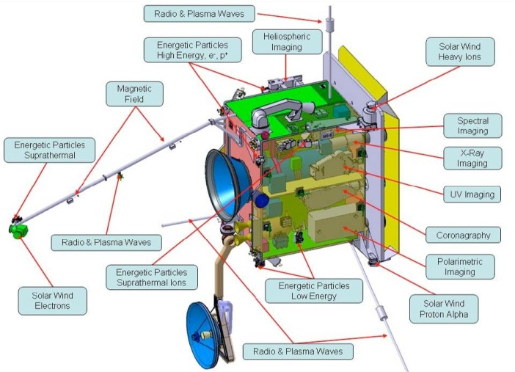
Figure 1. STIX location on board of Solar Obiter.

INSTRUMENT
The STIX instrument consists from three mechanically separated parts (Figure 2, left):
- An X-ray transparent window in the heat shield,
- An imager,
- Detector/Electronics Module.
From functional point of view, the STIX can be divided into seven subsystems (Figure 2, right):
- X-ray windows,
- Imager,
- Aspect System,
- Attenuator,
- Detectors + ASICs and ADCs,
- IPDU,
- PSU.
The individual subsystems are briefly described in the following sections. The instrument properties are summarized in Table 1.
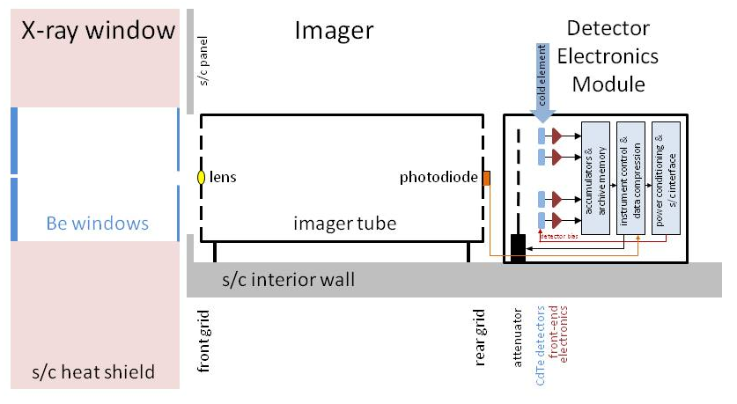
Figure 2. Left: The STIX instrument is made up of three mechanically-separate sections: the X-ray windows; the Imager with widely separated grids and aspect system; and the Detector/Electronics Module containing CdTe detectors and electronics. Right: Functional block diagram of the STIX instrument.

Table 1. Instrument properties.
Mass | 4.9 kg
Power | 5 W
Dimensions | 22 × 22 × 80 cm
Energy range | 4-150 keV
Energy resolution | 1 – 15 keV (depending on photon’s energy)
Field of view | 2°
Finest angular resolution | 7 arcsec
Spatial resolution | Up to 1400 km on the Sun (1/1000 of the solar diameter)
Time resolution | ≥ 0.1 s

X-ray windows
The STIX X-ray windows play two roles. First, they are a prime element in the instrument thermal control system, reflecting and reradiating most of the incident radiation, so as to limit the incident optical and IR solar flux seen by the instrument. Second, it serves to preferentially absorb the intense flux of low energy X-rays that would otherwise contribute to pulse pileup and live time issues in the detectors in large flares. By using low-Z materials, a thermally-effective window can be developed which has acceptable X-ray absorption properties to permit observations down to 4 keV.

Imager
The imager module consists of an end-mounted, 550 × 185 mm diameter aluminum tube whose purpose is to separate and support two grid assemblies, one at each end, while maintaining their relative twist. Each grid assembly consists of a tungsten grid that is divided into 32 subcollimators. The grid elements associated with each subcollimator consist of a set of alternating equispaced slits, and X-ray opaque slats. The subcollimator dimensions are 15 × 15 mm.
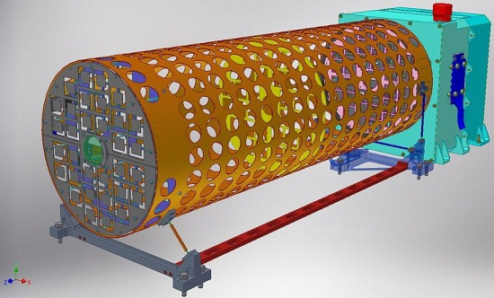
Figure 3. STIX Imager.

Aspect System
The Aspect System is used to measure the offset between the STIX Instrument Line of Sight and the spacecraft’s aspect system. The nominal spacecraft attitude control system requirement is sufficient for STIX to produce images without compromising its 7 arcsecond resolution. However, absolute placement of such images on the Sun makes use of the post-facto aspect solution and requires accurate knowledge of the offset between the STIX imaging axis and the spacecraft aspect system. This offset must be calibrated in flight at the ~4 arcsecond level. Because of the stability of the thermal environment, it is anticipated that only occasional (every few days) cross calibration is required. Between calibrations, the aspect system also provides a continuous measure of this offset. This is accomplished with the STIX internal aspect system and does not require any specific spacecraft operations.
The Aspect System consists from 4 photodiodes, 10 temperature sensors and associated electronics e.g. ADCs converters, linear regulators. Figure 4 shows the Aspect System seen from top.
Figure 4. Aspect System seen from top.

Attenuator
A mechanical attenuator that is inserted autonomously by the IDPU, is mounted to the front of the Detector Box to reduce the count rate of low energy photons during intense events.
It consists from two DC/DC motors (main and redundant) and HOP attenuator. Using the motors, the Attenuator can be set only in two positions: open or close. The HOP is used when there is a failure of the DC/DC motors and the attenuator cannot be moved. The HOP can be activated only once. After activation the attenuator moves to permanent “close” position. Figure 5 shows the Attenuator elements.
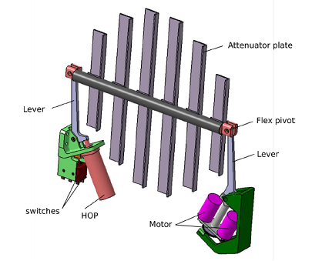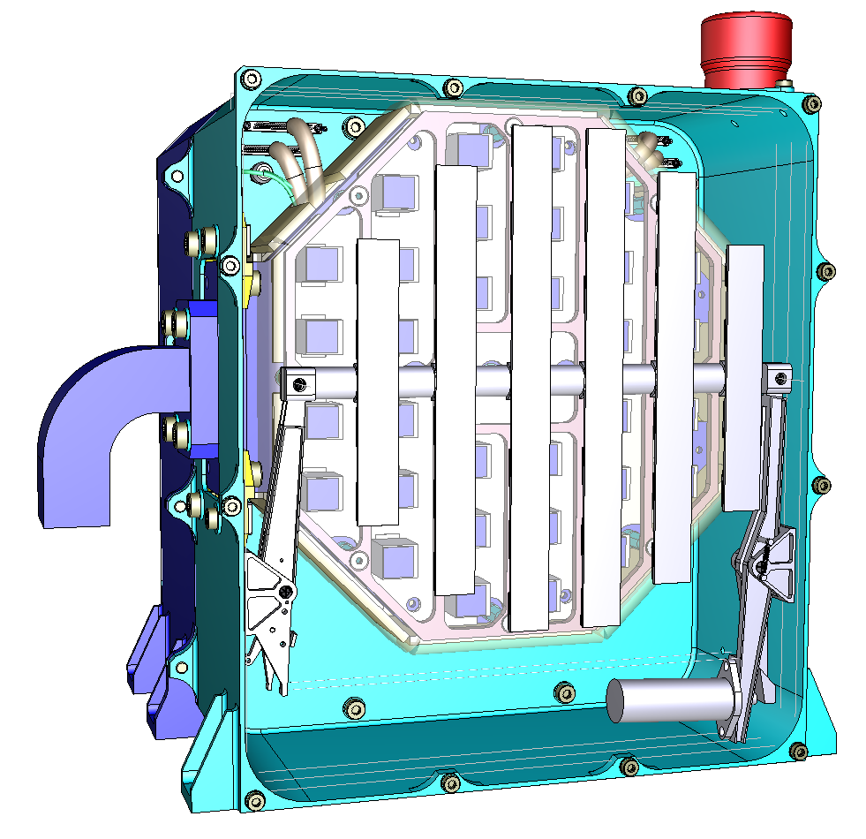
Figure 5. Left: Attenuator components. Right: Attenuator mounted on DEM Box seen from top.

Detectors and ASICs/ADCs
The STIX has 32 Cadmium-Telluride (CdTe) detectors [6]. A singe detector size is 10 × 10 × 1 mm³. Each detector consists of four identical side-by-side areas (stripes). Each stripe has 2 large pixels and 1 small pixel, giving a total of 12 pixels on each chip (Figure 6, left). The 8 large pixels and 4 small pixels are arranged in an asymmetrical geometrical configuration surrounded by a guard ring. The pixel effective areas range from 9.7 mm² for the big and 1.0 mm² for the small ones. A 50 µm wide electrode-free zone separates each adjacent pixel and the guard ring and pixel.
The detection unit of STIX is called Caliste-SO (Figure 6, right). The volume of the device is 12 × 14 × 17 mm³. The Caliste-SO integrates the functions of X-ray absorption with a CdTe semiconductor detector and analog front-end electronics with a full custom ASIC named IDeF-X HD [7]. Analog-to-digital converters are used to convert the analog output signals from a detector/ASIC to a digital form.
The detectors in the STIX are organized in four quadrants. Each quadrant contains 8 detectors and associated ASICs. Two detectors are connected to a single ADC converter, thus there are four ADCs per one quarter.
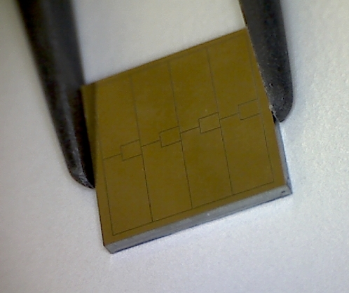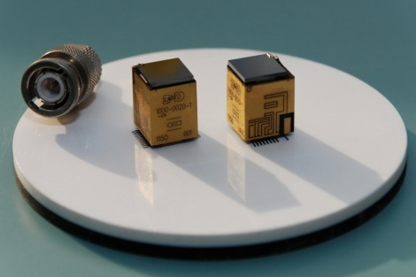
Figure 6. Left: CdTe detector used in STIX. Right: Caliste-SO spectrometer units.

IDPU
The Instrument Data Processing Unit (IDPU) includes CPU microprocessors, memories for data accumulation and software. It interfaces to the Payload Data Management Unit, a housekeeping system and other STIX electronics. A combination of low level state machines and high level software allows the IDPU to control and acquire data from Caliste units, make readouts from diodes in the Aspect system, manage the memories and control the attenuator and the power supply units (PSU). Since the Solar Orbiter during its orbiting around the Sun will not be seen from the Earth, the IDPU has to work fully autonomously.
The central element of the IDPU is a Field Programmable Gate Array (FPGA) from Actel’s RTAX S/SL family (Figure 7). The FPGA is connected to an Electrically Erasable Programmable Read Only Memory (EEPROM), a Random Access Memory (RAM) and a Flash memory. The EEPROM serves as a storage element for Start-Up software and is used only during the start-up of the system. The RAM consists of two chips with 64 MB size, thus giving 128 MB memory in total. The RAM has double functionality. While half of it is used as an operation memory for the application software, the other half serves as a rotating buffer for data coming from the detectors. The Flash memory with capacity of 16GB functions as an archive memory that allows us to store several months of scientific data. Additionally, the Flash memory contains two copies of the application software, which is used during the instrument operation. The microprocessor used in the IDPU is Leon 3FT from Aeroflex and is loaded into the FPGA. The processor is extended by an error detection and correction intellectual property (EDAC IP) core. The EDAC allows correcting one bit-error and detecting two bit-errors in 32-bit word at a time. Memory scrubbing for archive memory is employed as well.
Internal housekeeping (HK) of the instrument is a part of the IDPU. It consists of four analog to digital converters and additional analogue circuitry.
The IDPU consists of two functionally and electrically identical printed circuit boards (PCB): main and redundant. It communicates with the spacecraft via SpaceWire. The SpaceWire interface makes use of a controller implemented in FPGA and external physical-layer transceivers. The SpaceWire can be used to communicate with the spacecraft via two links, but only one of them is active at a time. The SpaceWire is cross-coupled to both IDPU PCBs and thus operates in warm redundancy concept. This means that if one link fails there is no need to switch the IDPU to redundant unit. The IDPU itself operates in cold redundancy concept. It means that if a malfunction of the IDPU component occurs, the whole unit has to be switched to the redundant PCB. Since each of the IDPU PCB is supplied from the PSU independently without cross-coupling, the switching to the redundant PCB is done by the spacecraft by switching to the redundant PSU.
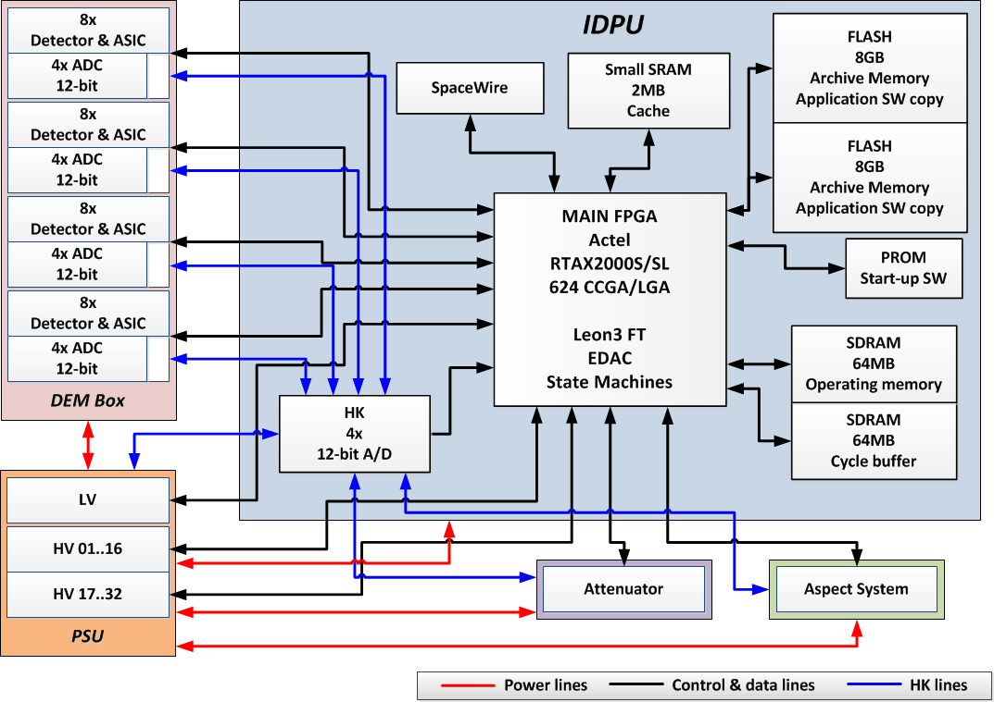
Figure 7. Logical block diagram of IDPU.
The IDPU together with PSU are enclosed in a mechanical box (Figure 8). The box size is 220 × 190 × 90 mm³. The enclosure has two compartments that are separated by a cross and stacked to it thin wall. The smaller compartment, located closer to the spacecraft interior, has depth equal to 29 mm. The PSU is located in this part of the box. The bigger compartment, located closer to the detectors is allocated to the IDPU.
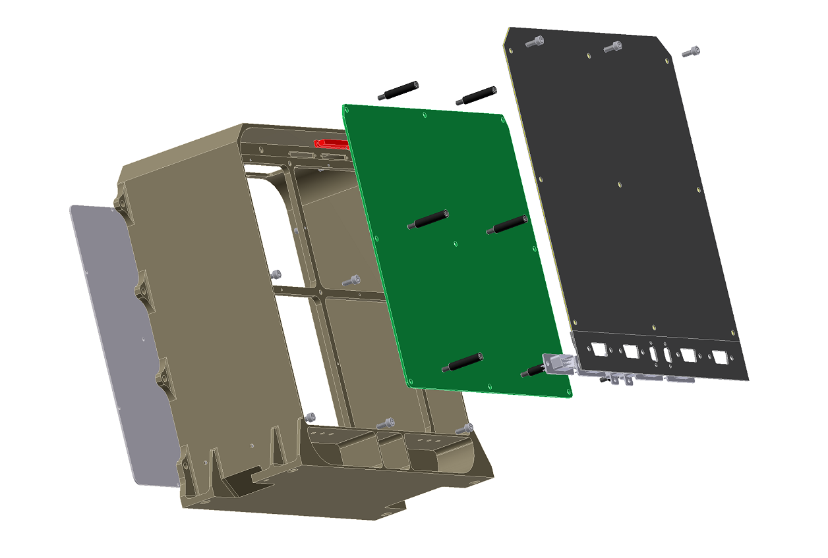
Figure 8. Mechanical enclosure of IDPU and PSU.
The software implemented in the IDPU consists of three components: the Start-up software (SuSW), Application software (AppSW) and Basic software (BSW). The SuSW is boot software that is always started right after the instrument is powered on. It checks the critical subsystems in the STIX instrument and after that it executes the AppSW. The AppSW, as its name suggests, is the main application used when the STIX instrument is active. It works on the RTEMS operating system and performs high level operations such as: data compression, real-time data analysis for detecting and signalizing the flare to the s/c for optional transmission to other instruments, telecommand and telemetry services, high level control of STIX subsystems.
The BSW is an independent library that provides the drivers to access the hardware. It is used by both Start-up and Application software. There are two versions of the BSW. The first one, smaller, is stored in the EEPROM memory. It used by the SuSW and it is not possible to update it during the mission. This version contains only the drivers for most critical subsystems and IDPU’s components that are checked during the boot sequence. The list of implemented drivers in this version of BSW is shown in Figure 9.
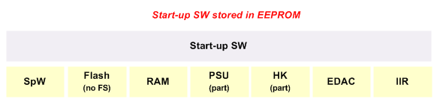
Figure 9. Basic Software drivers for Start-up SW.
The second version of BSW is larger and is used by the AppSW. It is possible to update it, since this version of BSW is stored in the FLASH memory. The full list of drivers in this BSW is shown in Figure 10. As can be seen, some of the drivers here are the same as used in the smaller version of the BSW. Indeed those drivers are the same, the only difference is that to the drivers from AppSW version a wrapper is added. Thanks that, the driver are compatible with the RTEMS operating system.
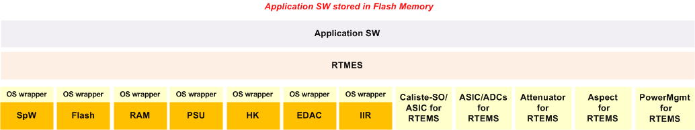
Figure 10. Basic Software drivers for Application Software.
The data flow in the STIX instrument is presented in Figure 11. The X-rays are detected by Caliste-SO detectors which generate triggers. These triggers are forwarded by ASIC electronic through LVDS lines to the IDPU. The state machines detect the triggers in the FPGA. After the detection, a series of control signals are sent to ASICs and A/D converters associated with them. These cause the conversion of the analog voltage levels that are proportional to X-ray energy to 12-bit digital values. These are then converted to 32 non-linear detector-matched energy channels for subsequent use. The counts are accumulated using variable duration accumulators, compacted and stored in the archive memory for subsequent data selection and compression. The memory is scaled to contain several months of data. The energy and time resolution of the archived data is such that no statistically or spectrally significant information has been lost. Data selection and compression algorithms are based on the on-board flare detection and adaptive algorithms, supplemented by specific requests from the ground. Other data processing functions include: quick-look data accumulations; live-time measurement; background monitoring; on-board coarse flare location; acquisition and compression of aspect data; and the quiet-time long-term accumulation of background counts with 10-bit energy resolution to monitor the detector energy calibration.
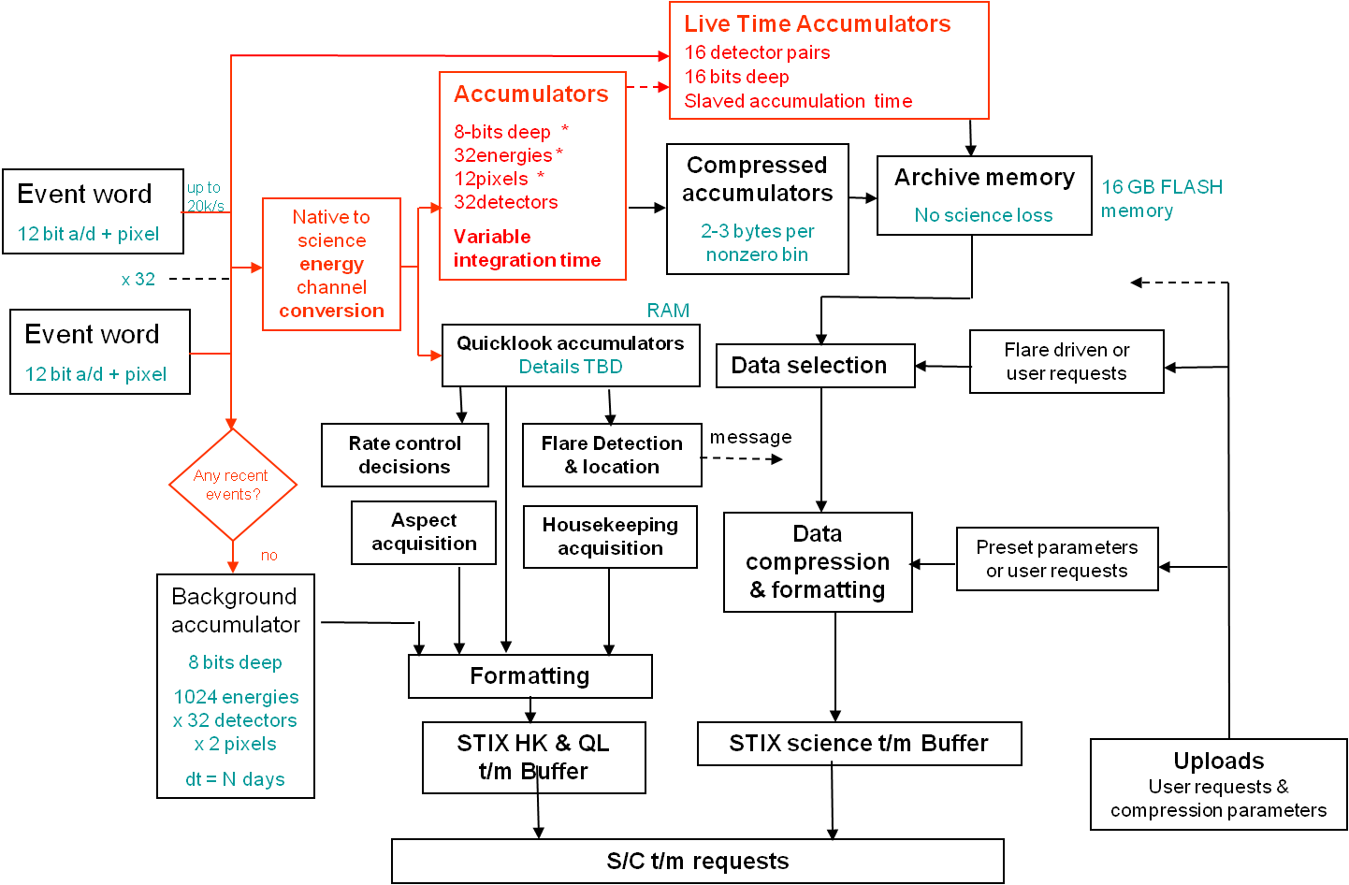
Figure 11. Data flow in STIX.

PSU
The Power Supply Unit (PSU) delivers a set of low and high voltages to the STIX. The low voltage part of the PSU works in cold redundancy concept. It is divided into two identical parts – nominal part and redundant part. These parts have separate circuitry, including connectors and input and output blocks.
The nominal low voltage source(LV) is connected to the main IDPU only. Analogously the redundant source is connected only to the redundant IDPU, thus there is no cross-coupling between these two sources and IDPUs.
The high voltage part (HV) operates in warm redundancy concept. It consists of two identical voltage sources that work in parallel. Each single HV supplies 16 detectors.
The PSU is fully controlled by IDPU. The IDPU sets the high voltage levels. It decides whether the PSU should deliver not only the essential voltages but also the non-essential e.g. used by ASICs or Aspect System.

Electrical Ground Support Equipment
The Electrical Ground Support Equipment (EGSE) is not a physical subsystem of the instrument, but is used to perform functional testing of STIX and its parts, analysis of instrument housekeeping data with appropriate displays and warning messages and provision for transitioning to a safe mode if necessary, simulation of the Solid State Mass Memory of Solar Orbiter On Board Computer, control and display of CdTe detector array performance and emulation of realistic detector signals.
The EGSE will simulate all connections between STIX and Solar Orbiter: Main and Redundant SpW Interfaces, Power Distribution Unit on spacecraft, the HPC and BSM Interfaces. The unit will be used for STIX activities at Instrument and DEM levels. For tests of Imager (Aspect) and Detector Electronics, Attenuator, IDPU and PSU levels the separate simulators will be provided.
EGSE contains Spacecraft Simulator, Workstation, EGSE Software and Data Stream Simulator. The three first items are the standard ones used for any of space missions. The fourth item is STIX specific – it covers the design and manufacturing of the special data pattern generator (called Data Stream Simulator). Figure 12 shows the EGSE block schematics.
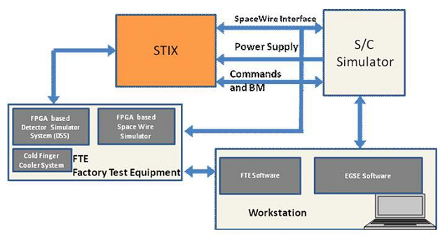
Figure 12. EGSE block schematics.

Thermal model of STIX
TBD - Agata

SUMMARY
TBD

References
- Kosugi et al., "The Hard X-ray Telescope (HXT) for the SOLAR-A Mission", Solar Physics 136 (1991) 17.
- Lin et al., "The Reuven Ramaty High-Energy Solar Spectroscopic Imager (RHESSI)", Solar Physics 210 (2002) 3.
- Hurford et al.,"The RHESSI Imaging Concept", Solar Physics 136 (2002) 61.
- Hurford G., et al., "The imaging concept for the spectrometer/telescope for imaging X-rays (STIX) on Solar Orbiter", Proc. SPIE 8443 (2012) 8443-130.
- Benz A., et al., "The spectrometer telescope for imaging x-rays on board the Solar Orbiter mission", Proc. SPIE 8443 (2012) 8443-131.
- Limousin O. et al., "Caliste 256: A CdTe imaging spectrometer for space science with a 580 µm pixel pitch", Nucl. Instrum. and Meth. A 647 (2011) 46-54.
- Michalowska A. et al., "IDeF-X HD: A low power multi-gain CMOS ASIC for the readout of Cd(Zn)Te detectors", Nucl. Sci. Symp. Conf. Rec. (2010) 1556-1559.

kskup@cbk.waw.pl;

