SphinX X-ray Spectrophotometer.

Mirosław Kowaliński
Space Research Center, Solar Physics Division, ul. Kopernika 11 Wrocław, 51622 Poland

ABSTRACT.
This paper presents assumptions to a PhD thesis. The thesis will be based on the construction of Solar Photometer in X-rays (SphinX). SphinX was an instrument developed to detect the soft X-rays from the Sun. It was flown on board the Russian CORONAS-Photon satellite from January 30, 2009 to the end of November, 2009. During 9 months in orbit SphinX provided an excellent and unique set of observations. It revealed about 750 flares and brightenings. The instrument observed in energy range 1.0 - 15.0 keV with resolution below ~0.5 keV. Here, the SphinX instrument objectives, design, performance and operation principle are described.
Below results of mechanical and thermal – vacuum tests necessary to qualify the instrument to use in space environment are presented. Also the calibration results of the instrument are discussed. In particular detail it is described the Electrical Ground Support Equipment (EGSE) for SphinX. The EGSE was used for all tests of the instrument. At the end of the paper results obtained from the instrument during operation in orbit are discussed. These results are compared with the other similar measurements performed from the separate spacecraft instruments. It is suggested design changes in future versions of SphinX.

Keywords : Spectrophotometer, Sun: ﬂares, Sun: X-rays

- INTRODUCTION.
The Solar Photometer in X-rays (SphinX) was developed in Space Research Centre, Solar Physics Division, PAS. The key idea behind the SphinX project development was to deliver a fast spectrometer that could provide good quality measurements of soft X-ray flux in its entire variability range which extends over seven orders in magnitude.
The main tasks of the instrument was an investigations and monitoring of solar soft X-ray flux in the energy
range ~1.0 – 15.0 keV. The investigation in this spectral range play a crucial role in:
- physics of solar corona, determining plasma diagnostics parameters, research on coronal heating mechanisms, physics of flares
- space weather and climate
- verification of the novel, fluorescence based, photometry measurement method
- development of a reference photometric standard in soft X-rays with absolute accuracy better than 10%.

This instrument was located inside Ultraviolet Telescope TESIS designed at the Lebedev Physical Institute of the Russian Academy of Sciences (FIAN, RAS) on board the Russian Satellite CORONAS-Photon ( fig. 1).
In this paper assumptions to PhD thesis of the author are presented.
The next sections give a detailed description of the design with emphasis on the contribution of the author.

Figure 1. The CORONAS-Photon satellite on a top the Cyclone-3M buster placed horizontally. Locations of SphinX (within TESIS) and STEP –F (charged particles monitor) are indicated in the picture.

- Comparison SphinX characteristics with other similar orbiting instruments.
The Spectrophotometer SphinX was measuring solar X-ray flux in the energy range ~1.0 – 15.0 keV. There are relatively few instruments which are taking or measured before solar flux in the same or similar energy range.
Among them the important are:
- RESIK (REntgenovsky Spektrometr s Izognutymi Kristalami), 2001 - 2003
- GOES (Geostationary Observational Environmental Satellite X-ray Flux Monitor ), since 1975
- RHESSI (Ramaty High Energy Solar Spectroscopic Imager), from 2002 onward
- SOXS (SOlar X-ray Spectrometer), 2003 - 2011
All these instruments have a much poorer sensitivity and temporal resolution than SphinX.
None of these instruments have been calibrated absolutely with a photometric accuracy better than 5%. as is in the case for SphinX.
RESIK (Sylwester et al., 2005) a bent crystal x-ray spectrometer, was built also entirely in Wroclaw by the Solar Physics Division Team of Space Research Centre Polish Academy of Sciences (SRC-PAS).
In RESIK the X – rays diffracted, according to the Bragg law, from the crystals were detected by one-dimensional position-sensitive sealed gas proportional counters. Although energy resolution Full Width at Half Maximum (FWHM) was approximately 19%, and area of the detectors was large the overall quantum efficiency of the instrument was lower than for SphinX. This was related to rather low coefficient of reflection used in RESIK to disperse incoming X-rays.
The instrument was able to record spectra from events of the GOES class above A4.0.
The SOXS (Jain et al., 2005) on board GSAT-2 the Indian spacecraft was operating in a geostationary orbit
from May 2003 to May 2011.

SOXS was equipped with the same type of PIN detector as SphinX was. Also front – end electronic was very similar to SphinX construction. For these reasons, this instrument will be compared with SphinX in this PhD thesis in more detail.
RHESSI (Lin et al., 2002), the other instrument operating in a similar energy range was launched by NASA in 2002 and is still functioning in orbit. This instrument uses nine large volume germanium detectors, sensitive to X rays in the energy range extending above 3 keV, up to 17 MeV, to measure soft and hard solar X-rays. The SphinX measurements can be compared directly with RHESSI in the energy range between 3 and 6 keV. The SPHINX detectors were much smaller than the RHESSI ones so are less sensitive to particles hits. During the low solar activity periods, due to large volume of detectors, a substantial orbital background is seen in RHESSI data. In the SPHINX measurements strong orbital background was seen only during spacecraft passages through polar fringes of Van Allen radiation belts and South Atlantic Anomaly (SAA).
The GOES XRM operate from geosynchronous orbit. The sensitivity of XRM detectors are 100 times worse than for SphinX, in similar energy band For weak solar fluxes the GOES XRM records are unphysical, drawn at the lower sensitivity threshold value.

An example of GOES, SphinX and RHESII data are shown in figure 2.
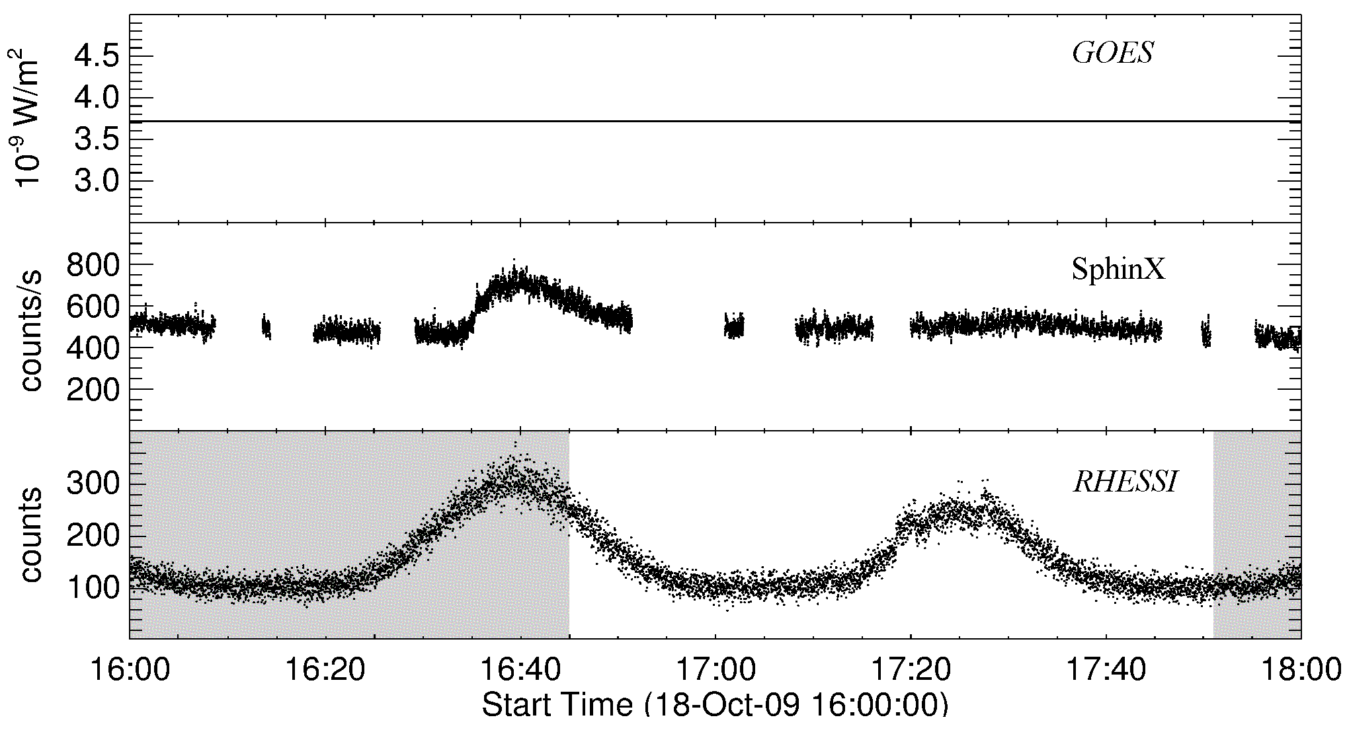
Figure 2. Comparison of solar X-ray observations taken on October 18, 2009. Top - GOES light curve in 1.5–12.4 keV channel. The GOES line is entirely flat and represents the instrument sensitivity threshold. In the middle panel SphinX data in the same energy range as for GOES is plotted. Bottom - RHESSI light curve in 3.0 – 12.4 keV. The substantial modulation from orbital background is seen in RHESSI lightcurve.

- SphinX construction.

  - Detectors.

In figure 3, the construction of XR-100CR X-ray detector used in SphinX is presented. SphinX was equipped with four such detectors, provided by Amptek Inc., Bedford, MA., U.S.A. These detectors are 500 µm thick, pure silicon PIN diodes with entrance windows covered with 12.7 μm thick beryllium foil. Each silicon detecting layer is housed on the top Peltier element and is equipped with FET transistor inside with TO-8 package (fig. 3).
In order to decrease the thermal noise they were operate in flight at temperatures below -20 °C.

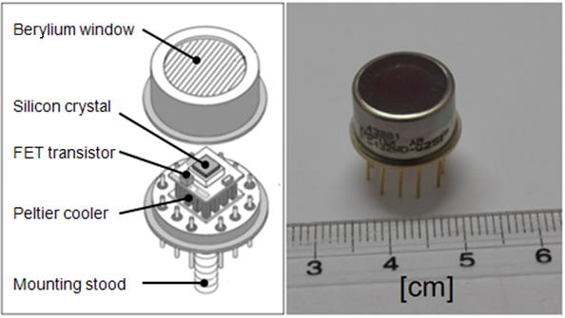
Figure 3. Amptek PIN detector XR 100-CR.

During SphinX (Sylwester et al., 2012) development it was planned to observe solar X-ray flux in its entire variability range which covers seven orders of magnitude. A single, unobscured, XR-100CR detector can measure correctly only the solar flux at low levels, below class B5.0, corresponding to count rates of 10^4. For stronger events the saturation effects become important. In order to extend the range of measurements, the other SphinX detectors were equipped with collimators of reduced apertures. In the flight configuration the SphinX X-ray detector assembly came up with one detector (D1) of the entrance aperture of 21.50 mm² (the nominal factory entrance window area), the second one (D2) with aperture of 0.495 mm² for measuring moderate X-ray fluxes and the third (D3) with aperture of 0.01008 mm² for measurements of the strongest flares. This configuration of aperture setting allowed to cover seven orders of expected variability of solar flux.

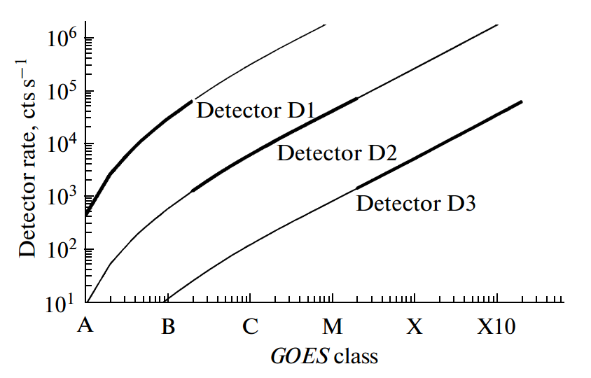
Figure 4. The dependence of expected count rates of SphinX deteectors on the X-ray class of the flare. Description of X-ray classes can be found on http://spaceweather.com/glossary/flareclasses.html. Horizontal shift of the lines reflects differences in area of entrance apertures.

The detector D1 with the largest effective area is designed to measure low intensity solar photon fluxes.
The aperture of the second detector D2 was chosen so that it gives good signal/noise ratio (S/N) measurements during moderate solar fluxes for which pileup in D1 starts to appear. The third detector D3 with the smallest aperture can
measure substantial signal for strong solar flux when pileup in detector D2 becomes important (detector D1 completely saturates at such flux levels). Simulations of detectors sensitivity are presented in fig. 4
The fourth detector D4 was in SphinX fluorescence measurement channel which was designed to measure characteristic, narrow band X-ray fluorescence excited by X-ray solar illumination. The SphinX fluorescence channel needed a stronger solar flux to obtain useful signal above the noise level. Unfortunately, the instrument operated during a period of very low solar activity, when there were no flares large enough to rise the signal above the noise.

  - The electronics of Sphinx.

The electronic hardware design of the instrument is composed of main microcontroller (µC), the system based on ATMega2561 processor, and four analogue signal processing chains. The µC was connected to TESIS computer.
There were use 3 types of connections:
- Serial Programming Interface (SPI) for reprogramming µC program flash memory
- RS232 synchronous data transfer rates up to 38.4 kb/s. It was used to control SphinX µC
- Manchester II protocol for the telemetry – 1 Mb/s.
The block diagram of the electronic design is shown in fig. 5.

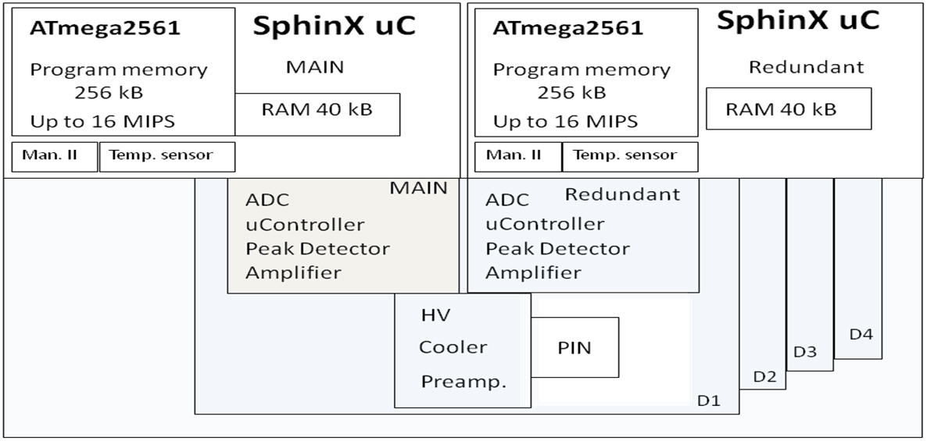
Figure 5. Block diagram of the SphinX electronics.

The main µC was also connected to analogue cards. Each of these cards was equipped with the microcontroller ATTINY26 (which could also be separately reprogrammed) and the analogue signal processing chain.
The microcontrollers on the analogue cards were used to:
- control detectors temperature in the feedback control
- supply of Peltier elements by Pulse Width Modulation (PWM) method
- switch on and off the high voltages (+150V) on the detectors
- read housekeeping data.
The simplified schematic of analogue signal processing chain with the shaping amplifiers is presented in fig. 6. The reset-type charge sensitive preamplifiers was provided by Amptek [ 8]. The rest of the elements of the chain has been designed and integrated in the electronic laboratory of SRC in Wrocław. The parameters of amplifiers were chosen to get the good counts statistic (50-60 kcnts/s for D1 and 20 kcnts/s for the rest of detectors) and resolutions (FWHM) better than below 0.5 keV at 5.9 keV.
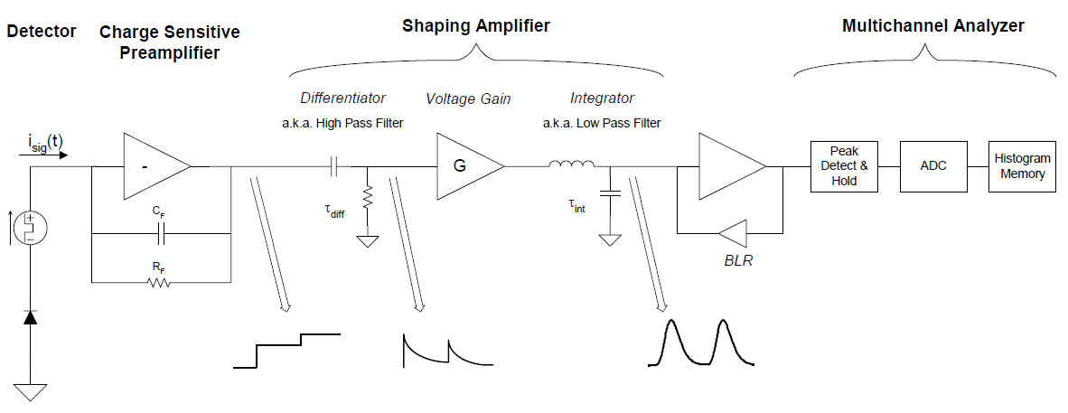
Figure 6. Schematic diagram of a simple analogue pulse shaper (with CR-RC² shaping).

- Sphinx - Software.

  - The Flight Software.

The flight software for SPHINX was written in C language. To speed up main microcontroller (µC) some procedures have been written in assembler. It also helped to control the execution of the program at the level of individual clock
cycles. The size of the software is about 30 kbytes for the main µC (ATMega2561/ 16MHz ) and approximately 1 kbyte for peripheral controllers (4 x ATtiny2313/ 12MHz).
The program is divided into the following functional blocks:
Communication with TESIS computer. Procedures, in this section, managed following connectors: RS232, Manchester II and SPI. Through the RS232 connector TESIS could send commands to SPHINX. This feature allowed to switch on/off PIN detectors directly by radio.
The scientific and housekeeping data were sent through Manchester II (1 Mb/s) connection. Next these data were packed with the current Universal Time Clock provided by TESIS mother computer into telemetry frames. The data were sent to the Ground Telemetry Stations through SSRNI (System of Collection and Registration of Scientific Information) developed at Institute of Terrestrial Magnetism, Ionosphere and Radio Wave Propagation of the Russian Academy of Sciences, Troick (IZMIRAN) and then, after splitting from the overall telemetry stream, they were sent through the internet to SRC-PAS (http://www.cbk.pan.wroc.pl). Daily volume of SPHIINX data was 70 - 150 Mbytes compressed data.. A single data file typically covers a couple of hours of the observing time and contains several thousands of telemetry frames. After that, data were unpacked from telemetry frames, decompressed and saved in Interactive Data Language (IDL) native format.
Another useful option, used a few times during the mission, was reprogramming the flash memory of SPHINX main µC remotely through dedicated uplink from the ground station. This uplink was possible during direct telemetry session, when the space craft was within the visibility range. This mode of commanding was used successfully several times.
In the dedicated onboard software block were included procedures for handling controllers in the analogue cards. Main µC controlled temperatures of detectors, high and low level voltages of power supply. There were also procedures stored for reprogramming the flash memory of controllers from analogue cards.
Computing procedures. As a part of the on-board software, a simplified data compression procedures have been used.
The algorithm was based on LZW method (Mark Nelson 1995) - the universal lossless data compression.
The effective, average compression factor for the data collected in spectral mode (Sphinx operation modes are described below) was between 6 and 10 and for Time Stamping mode it was in the range 1.5 – 3.0.
For its optimum operation, the Russian UV Telescope TESIS needed information on solar flares in progress, in particular on the time when the flare starts. Therefore a special algorithm for detecting flares in progress was implemented within the flight software.
Another important satellite "environment" condition was the X-Ray illumination on or off. A dedicated algorithm implemented onboard was predicting times when the satellite entered or was leaving the X-ray shadow cast by Earth. During spacecraft nights, the amount of information to be transferred to the ground was much less, and the spectral mode of data collection was preferentially used. During illuminated parts of the orbit, the time stamping mode was preferentially used.
The management of detector signals. The main µC was incorporating several modes of operation, depending on the environmental data and the scientific tasks to be achieved.
In the Basic mode the whole spectrum covering 256 spectral bins was combined into 4 channels. The distribution of bins in the channels is shown in fig. 7.

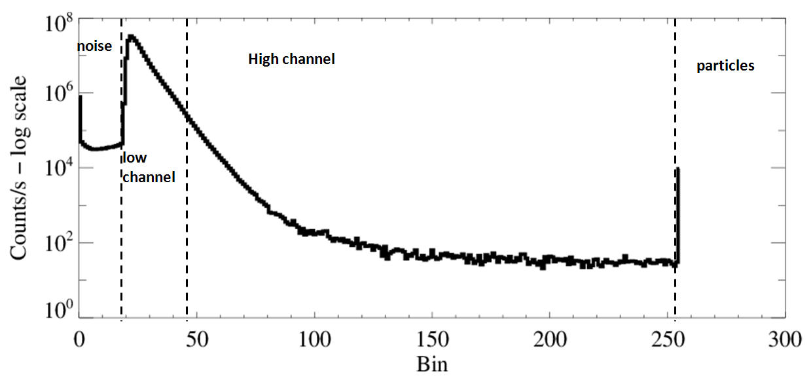
Figure 7. Typical shape of the SphinX spectrum (thick line) with superposed channels allocation in the BASIC mode. The spectrum was collected from 1 to 31 May 2009.

In the lowest energy channel (code name „0”) covering bins between 0 and 17, the noise coming from the electronic was contributing the most to the signal. In channel 1 the main contributor were counts due to X-ray photons of energy 1.0 -3.0 keV, in channel 2 the photons of energy between 3.0-14.9 keV. In the last, highest energy channel of two bin width, the dominant contributors were the instrumental detectors resets and counts of large amplitude coming from interaction of radiation background high energy particles.
In the spectral observing mode SphinX collected the information on the distribution of detector events on amplitude (energy). This formed a histogram of counts vs bin number for given data gather time interval (DGI).
This measurement method is known as pulse height analysis (PHA). It was switched on only during the satellite nights lasting for about 20 minutes per orbit. For CORONAS-Photon satellite the orbital period was around 95 minutes.
In the Time Stamping mode (fig. 8) detector event amplitude (photon energy - one byte) and the time of arrival (three bytes) were stored for subsequent compression and transfer to the telemetry stream.

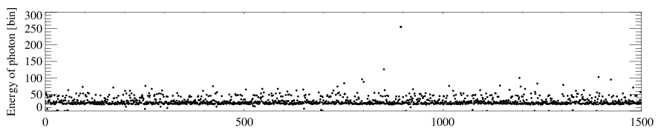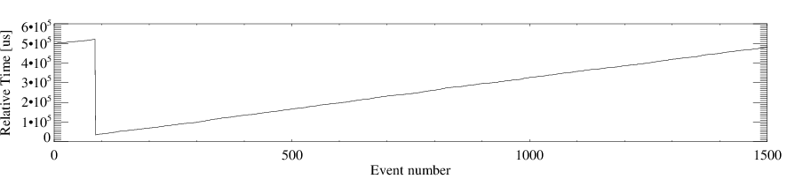

Figure 8. The energy of photons is plotted in the top panel and arrival time on the bottom one. In the time graph a jump related to rollover of the most significant byte in the time counting memory cell is visible. In the top plot, each detector event (count) has the vertical location proportional to the event amplitude.
Individual pulse arrival times were determined with the 1 μs accuracy. The analogue system could distinguish and correctly measure amplitudes of two pulses occurring not closer than ~6 μs one after another. If time delay between two successive pulses was less than ~6 μs they overlapped and the electronics (shaping amplifier and peak detector) measured higher amplitude than the amplitudes of individual contributing pulses. Such close-in-time arrival of impulses
caused the pile-up effect and contributed to dead time effects in data.

  - The Electrical Ground Support Equipment.

The Electrical Ground Support Equipment (EGSE) was designed jointly with colleagues from FIAN (P.N. Lebedev Physical institute of the Russian Academy of Sciences, Moscow). They have provided the hardware based on the FPGA and µC made by Analog Device. The software for this hardware has been written and verified in SRC, Wrocław. The software was written myself in C++ for Visual Studio 6.0. An example of the screen dump is presented on fig. 9.

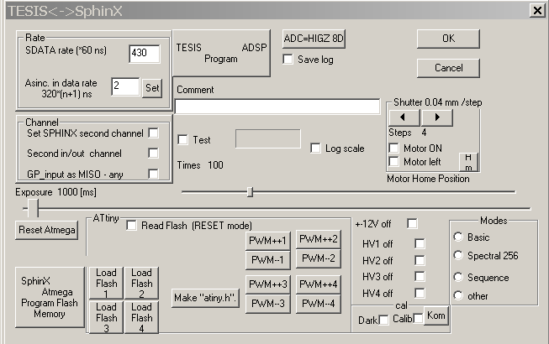
Figure 9. The figure shows a dialog box with several buttons, check boxes to control the behavior of SphinX.
The SphinX EGSE main features are the following:
The EGSE could fully simulate all connection with TESIS. This allowed to test telemetry system, commanding and on-board read and write flash memory without the physical connection with the mother THESIS and the rest of the satellite. Another useful feature are procedures for data archiving. Within EGSE it is possible to read the packed telemetry frames and display the spectra for each ground measurement. The EGSE took part in all the tests, instrument calibrations and the design of Sphinx. The EGSE was also used during calibration of the instrument at Berlin BESSY synchrotron and XACT Facilities in Palermo.
The EGSE which was based on the Windows PC laptop workstation includes also functions to perform the pre-launch, autonomous and End – to – End tests. This functionality allowed to inspect frequently the overall health, routinely when the instrument was powered.
- Instrument tests and calibration.

  - The thermo-vacuum tests.

The objective was to verify if SphinX instrument can operate successfully in typical space vacuum conditions i.e. in the temperature range from -20°C to +50 °C. Sphinx should perform measurements under such extreme environmental conditions in the Low Earth Polar Orbit (LEO) environment. Figure 10 presents the instrument undergoing the thermo-vacuum tests. Results of the tests indicate that the instrument electronics and all moving parts within the instrument reacted nominally to the pressure and temperature changes requested by the Russian authorities responsible for spacecraft quality assurance.

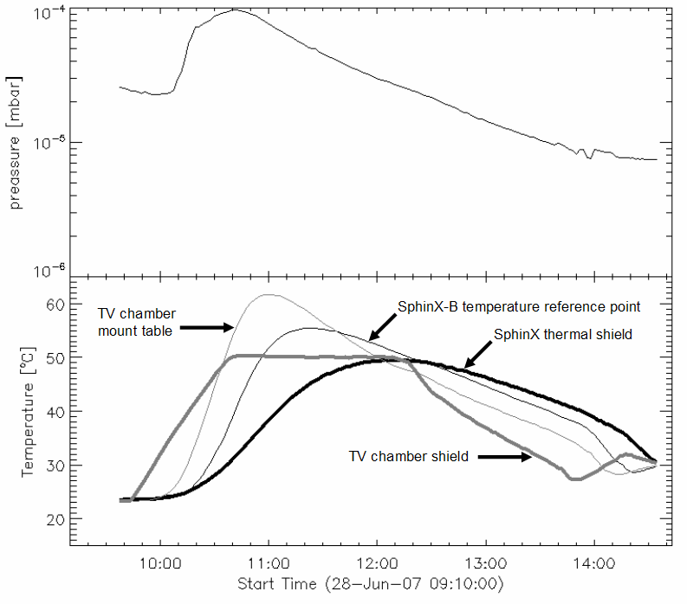
Figure 10. Example test results are presented on both graphs. In the upper graph, the time variation of pressure
in the chamber is given, while in the bottom part respective change of temperature within the instrument.

  - Mechanical tests.

In order to verify that the mechanical construction and the overall structure of the instrument is rigid enough for mechanical loads and vibration during transport and the rocket launch, the instrument was tested mechanically. The tests were performed in accordance with Russian Standard “ТЕХНИЧЕСКИЕ ТРЕБОВАНИЯ ДЛЯ РАЗРАБОТКИ АУЧНЫХ ПРИБОРОВ И АППАРАТУРЫ ПРОЕКТА “КОРОНАС – ФОТОН” in the Aeronautical Research and Test Institute in Prague Czech.

Table 1 The frequency and amplitude range of tests the SphinX instrument passed successfully.
TEST | Amplitude | Frequency
Acoustic vibrations | 122 dB – 133 dB | 35 Hz - 5 kHz
Acceleration | 3 g, 10 g* | 10 min
Transports in 3 axes | 9g | 5 ms-10 ms, 120 shock/min
Resonance | 50 g | 10 Hz - 2 kHz
Vibration overload | 2 g -80 g | 10 Hz - 2.5 kHz
Shocks in 3 axes | 80 g | 2 ms
- g = 9,81m/s^2 – unit of acceleration at the surface of Earth
An example of transport tests is presented in fig. 11

Figure 11. The plot showing behavior of forced acceleration applied along the Z-axis of the instrument.

  - Calibration.

It is of prime importance to perform a detailed ground calibration of the instrument before launch. Results of the calibrations were used to determine so-called instrument response matrix DRM. This matrix is used to convert the measured count rates and spectra into absolute values of the flux and spectral irradiance. SphinX was the first ever instrument which underwent such a detailed ground test procedures. The pre-flight X-ray calibration program was performed in two phases. The preliminary phase was accomplished in Palermo at the X-ray Astronomy Calibration and Testing (XACT) Facility (Collura et al., 2008, Gburek et al., 2011a). XACT consisted of the X-ray laboratory source placed in the long 35 m vacuum tube. Entire SphinX detector with all detectors was illuminated by uniform beam
of X-rays. The illuminating X-ray spectra consisted of bremstralung continuum with superimposed characteristic K_{α} and K_{β} lines which energy depend on the selection of anode material. Several different anode materials were used to cover entire measurement energy range. Analysis of the spectra allowed to determine detector energy resolution and preliminary estimate the SphinX efficiency.
The final phase of X-ray calibrations were performed at the Physikalisch-Technische Bundesanstalt (PTB) calibration facility using BESSY II synchrotron as a primary X – ray source standard. PTB is the German National Metrology Institute. Two methods of illuminating the X-ray SphinX detectors were executed. In the first, the monochromatic (monoenergetic) beam of X-rays was formed using the four-crystal monochromator. The response of the detector showed the intrinsic instrumental width of each detector at various energies from the range 1.5 up to 10 keV.
Next the SphinX detectors were exposed to an undispersed continuum synchrotron radiation. Spectrum of such radiation (fig. 12) can be calculated and is known with a very high accuracy. Final results of all ground tests of the four SphinX detectors are summarized in Table 2.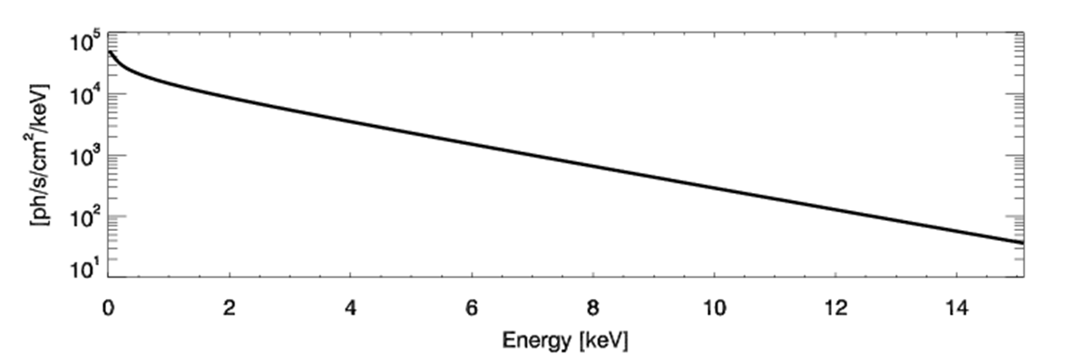
Figure 12 An example of the continuum synchrotron spectrum illuminating the detectors in the final stage of ground calibration at the BESSI Synchrotron in Berlin.
Table 2. The results of SphinX detectors calibration.
X-ray flux level | Low | moderate | High | High
Detector Name | D1 | D2 | D3 | D4
Observation type | Direct Solar  X-rays | Direct Solar  X-rays | Direct Solar  X-rays | Fluorescence
Aperture, [mm²] | 21.5 ± 0.5 | 0.4947 ± 0.003 | 0.01008 ± 0.00002 | 11.1 ± 0.5
Energy resolution FWHM,[ eV] | 480 ± 5.8 | 350 ± 4.0 | 370 ± 4.4 | 290 ± 3.8
Pulse width [μs] | 1.25 ± 0.01 | 4.17 ± 0.01 | 4.17 ± 0.01 | 4.17 ± 0.01
Energy range [keV] | 1.0 – 15 | 0.85 - 15 | 0.85 – 15 | 0.85 – 15

The results of calibrations were incorporated in determination of so-called SphinX Detector Response Matrix (DRM).
As is seen from table 2, the SphinX calibration procedures also allowed to determine uncertainties of the calibrated quantities. For data with good count statistics, the measurement accuracy was at the level of ~1%. The results of the ground tests indicated, that the recommended operational temperature of the detector crystals have to be below -20 °C.

- The flight results and conclusions.

The active phase of SphinX measurements started few weeks after the launch, on February 2009, thus allowing the instrument to outgas. The measurements were continued till end of November 2009, until the Coronas-Photon spacecraft was operational. Early in December, the contact with the satellite was lost and the mission ended much too early than expected (3 years guaranteed time). The reason of the satellite failure were problems with the power supply system.
Therefore the SphinX measurements cover only the phase of a deep minimum of solar activity observed in 2009.
It is worth to note that during this period no other instrument, but SphinX was sensitive enough to detect the X-ray signal from the Sun most of the time. Therefore the spectra collected by SphinX are unique, of basic importance for understanding the physic of processes of energy release in the coronal plasma heated to temperatures above 1 million K. The data are undergoing physical analysis and the first results have already been published in leading astrophysical journals (see Gburek et al., 2011b). Thanks to measurement taken by SphinX it is possible for the first time to study behavior of solar X – fluence at time of such low activity.
On-line public access to SphinX level-1 data has been allowed in a form of the Internet catalogue http://156.17.94.1/sphinx_l1_catalogue/SphinX_cat_main.html.
The catalogue also contains calibration information and all documentation necessary for data analysis.
The new, improved version of the SphinX instrument incorporating new type of the SDD detectors is under design at SRC - PAS. This Sphin_NG (new generation) will be put in orbit onboard the envisaged nano-satellite mission in collaboration with NASA and/or ESA. This improved instruments will consist a new standard could be a new standard in the measurements of the solar soft X-ray.

ACKNOWLEDGMENT
This work obtained support from grant no. N203 381736 of Polish Ministry of Education and Science. SphinX was developed within the framework of Polish Academy of Sciences and Russian Academy of Sciences bi-lateral agreement on cooperation in space research. The SphinX project also was partially supported by the Russian Foundation for Basic Research (project no. 08-02-01301-a), program for fundamental research of Physical Department of the Russian Academy of Sciences “Processes in Solar System Plasma”. The research leading to these results has received funding from the European Commission’s Seventh Framework Programme under the grant agreement n° 284461 (eHEROES project).

REFERENCES
[1] Collura, A., Barbera, M., Varisco, S., Calderone, G., Reale, F., Gburek, S., Kowalinski, M., Sylwester, J., Siarkowski, M., Bakala, J., Podgorski, P., Trzebinski, W., Plocieniak, S., Kordylewski, Z.: 2008, Calibration of the SphinX experiment at the XACT facility in Palermo, Proc. SPIE,, V. 7011, 70112U
[2] Gburek, S., Siarkowski, M., Kepa, A., Sylwester, J., Kowalinski, M., Bakala, J., Podgorski, P., Kordylewski, Z., Plocieniak, S., Sylwester, B., Trzebinski, W., Kuzin, S.: 2011a, Soft X-ray variability over the present minimum of solar activity as observed by SphinX, Solar System Research, 45, Issue 2, pp.182-187.
[3] Gburek, S., Sylwester, J., Kowalinski, M., Bakala, J., Kordylewski, Z., Podgorski, P., Plocieniak, S., Siarkowski, M., Sylwester, B., Trzebinski, W., Kuzin, S. V., Pertsov, A. A., Kotov, Yu. D., Farnik, F., Reale, F., Phillips, K. J. H.:2011b, SphinX soft X-ray spectrophotometer: Science objectives, design and performance, Solar System Research, 45, Issue 3, 189-199.
[4] Sylwester, J. ,Kowalinski, M., Gburek, S., Siarkowski, M., Kuzin, S., Farnik, F., Reale, F., Phillips, K. J. H., Bakala, J., Gryciuk M., Podgorski P., Sylwester, B.,: 2012, Sphinx Measurements of the 2009 Solar Minimum X-ray Emission, Astrophysical Journal
[5] Sylwester, J.; Gaicki, I.; Kordylewski, Z.; Kowaliński, M.; Nowak, S.; Płocieniak, S.; Siarkowski, M.; Sylwester, B.; Trzebiński, W.; Bakała, J.; Culhane, J. L.; Whyndham, M.; Bentley, R. D.; Guttridge, P. R.; Phillips, K. J. H.; Lang, J.; Brown, C. M.; Doschek, G. A.; Kuznetsov, V. D.; Oraevsky, V. N.; Stepanov, A. I.; Lisin, D. V., 2005 RESIK: A Bent Crystal X-ray Spectrometer for Studies of Solar Coronal Plasma Composition, Solar Physics, Volume 226, Issue 1, pp.45-72, DOI: 10.1007/s11207-005-6392-5
[6] Jain, R., Dave, Hemant, Shah, A. B., Vadher, N. M., Shah, Vishal M., Ubale, G. P., Manian, K. S. B., Solanki, Chirag M., Shah, K. J., Kumar, Sumit, Kayasth, S. L., Patel, V. D., Trivedi, Jayshree J., Deshpande, M. R.: 2005, Solar X-ray Spectrometer (Soxs) Mission on Board GSAT2 Indian Spacecraft: The Low-Energy Payload, Solar Phys., 227
[7] Mark Nelson. [The Data Compression Book], IDG Books Worldwide, Inc, (1995)
[8] AN-DPP-001: Digital Pulse Processors Theory of Operation Amptek Inc.
[9] Lin, R. P., Dennis, B. R., Hurford, G. J., Smith, D. M., Zehnder, A., Harvey, P. R., Curtis, D. W., Pankow, D., Turin,
P., Bester, M., Csillaghy, A., Lewis, M., Madden, N., van Beek, H. F., Appleby, M., Raudorf, T., McTiernan, J.,
Ramaty, R., Schmahl, E., Schwartz, R., Krucker, S., Abiad, R., Quinn, T., Berg, P., Hashii, M., Sterling, R., Jackson,
R., Pratt, R., Campbell, R. D., Malone, D., Landis, D., Barrington-Leigh, C. P., Slassi-Sennou, S., Cork, C., Clark,
D., Amato, D., Orwig, L., Boyle, R., Banks, I. S., Shirey, K., Tolbert, A. K., Zarro, D., Snow, F., Thomsen, K.,
Henneck, R., McHedlishvili, A., Ming, P., Fivian, M., Jordan, John, Wanner, Richard, Crubb, Jerry, Preble, J.,
Matranga, M., Benz, A., Hudson, H., Canfield, R. C., Holman, G. D., Crannell, C., Kosugi, T., Emslie, A. G., Vilmer,
N., Brown, J. C., Johns-Krull, C., Aschwanden, M., Metcalf, T., Conway, A.: 2002, The Reuven Ramaty High-
Energy Solar Spectroscopic Imager (RHESSI), Solar Phys., 210, P. 3

